Dear Supplier,
We would like to inform you that Yazaki NA is undergoing a transition from Mercury Gate to SAP S/4 HANA Transportation Management System. This strategic shift aims to enhance operational efficiency and provide better visibility into shipments.
Changes for Suppliers
- Introduction of a new supplier portal exclusively for creating transportation loads for truck shipments. *Note that the portal will not be applicable for ocean shipments.
- Implementation of a new format for the Bill of Lading (BOL#), which is now mandatory on the Advance Shipping Notice (ASN - 856) or needs to be input into SNC for suppliers not transmitting an 856.

What Remains Unchanged
- The overall process remains unaffected. While the user interface for the new Supplier Portal may differ, the functionality and the process itself remain unchanged.
- Suppliers are still required to include the BOL# on the 856 or input it into SNC when initiating a shipment. Please refer to the detailed requirements outlined below.

Preparation for implementation
Yazaki will be providing work instructions on how to create a load within the new system and where to locate the BOL# to put into the 856 or SNC. The step-by-by step written instructions can be found here and the video walkthrough can be found here.

Requirements for BOL# on all ASNs (856 or SNC)
Yazaki emphasizes enhancing visibility and traceability for inbound shipments by linking SAP BOL# to our deliveries in the SAP ERP system. We kindly request all suppliers to include the SAP BOL# in all 856 submissions. This requirement becomes mandatory for all 856 transactions to YNCA locations by 2/5/2024 and 2/26/2024. You can locate the BOL# in your TMS profile as a ten-digit numeric number starting with 61* (61xxxxxxxxx). Refer to the image below for clarification.
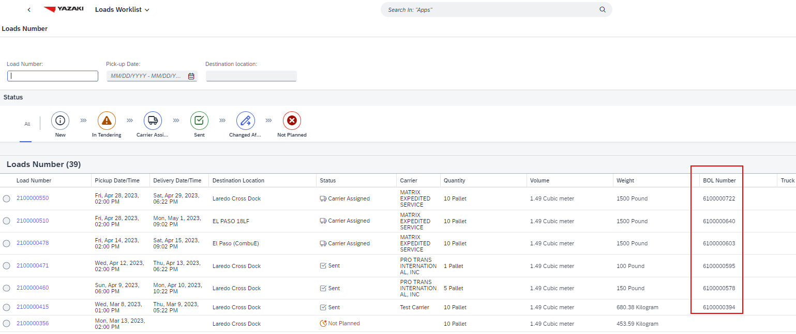
Please see below which fields will need the SAP BOL# value based on the method of ASN transmission. Those methods are:
- SNC, utilizing the Delivery Due List for Purchasing Documents
- SNC, utilizing the SNCUpload .csv file
- ANSI 856:005050 EDI file

SNC – Delivery Due List for Purchasing Documents
Under the Shipping Details tab, use field Bill/Lading No.
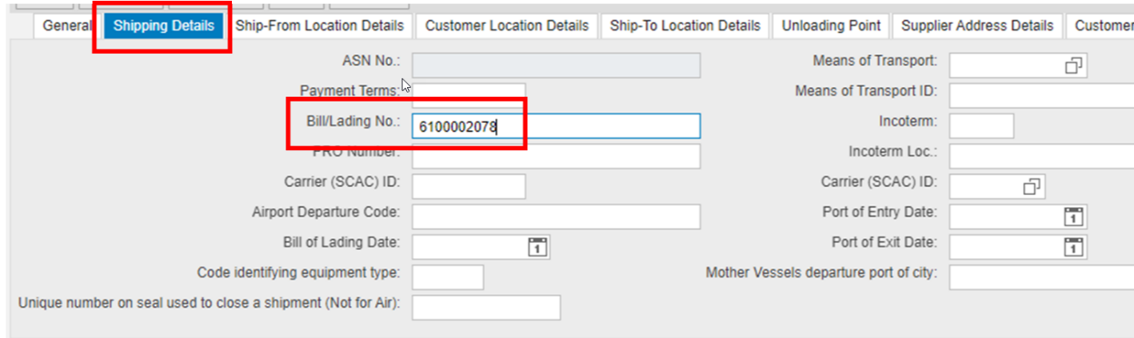

SNC – SNCUpload .csv file
Use Column I, titled Bill/Lading No.
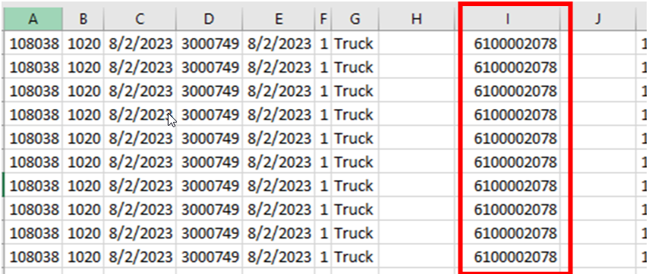

ANSI 856:005050 EDI file
Use the REF*BM segment of your 856 file
Segment: REF Reference Identification - Bill of Lading
Position: 1500
Loop: HL Mandatory
Level: Detail
Usage: Optional (Must Use) _
Max Use: 1
Purpose: To specify identifying information
Syntax Notes: 1 At least one of REF02 or REF03 is required.

Comments:
Notes: 1. At least one REF segment must be included in every 856 at this point to specify
the Bill of Lading Number (REF01 = "BM").
2. Use the SAP BOL# in this segment

Example: REF*BM*61xxxxxxxx~

Sample portion of an 856:005050:

HL*1**S
MEA*PD*N*2376*LB
MEA*PD*G*2376*LB
MEA*PD*T*0*LB
MEA*PD*VOL*5*CF
TD1*CTN71*108
TD5*B*2*PNII*LT
REF*BM*61xxxxxxxx
FOB*PP*CA*US*01*FCA*AC*Rancho Cucamonga, California
N1*SF*SUPPLIER*92*3000999
N1*ST**92*5116
N1*RI**92*3000999
Transportation Method is a mandatory field on the supplier 856. This is an existing requirement that is critical for our Transportation system.
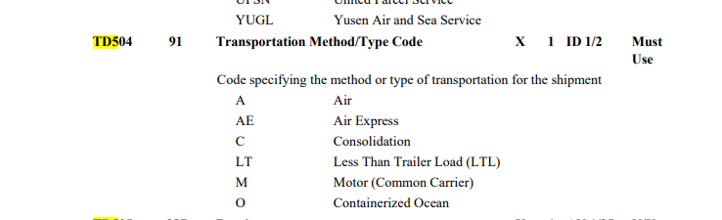

For inquiries regarding general procedures or issues related to the SAP TMS Portal, kindly direct your questions to SAPTMS_Support@us.yazaki.com.

